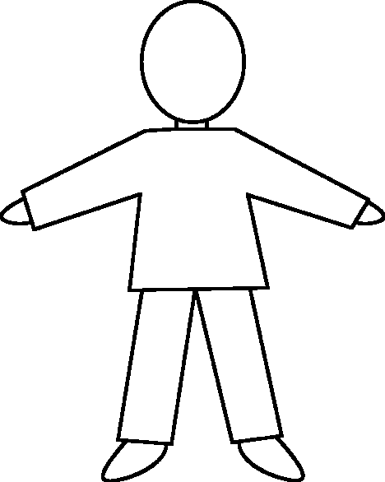
A Citizen I’d Like to Meet
(A head-to-toe composite drawing)

Outcome: Learners will analyse evolving concepts of citizenship in self, others, various groups of people, and various community constructs
Indicator(s): Investigate characteristics of Citizenship
Assessment Link: Here is a simple way to get the class to consider qualities of citizenship, and is an excellent “launch” activity and to note student contribution to the question “Who am I as a citizen?”

What you need:
Option One: Small composite drawings…
- A template like this one, any size (I got mine from clipartkids.com) for each person or each group.
- Markers, coloured pencils

Option Two: Big composite drawings…
- Chart paper, or Long paper roll in “kid-size” pieces- one for each group.
- Markers

Have students brainstorm the characteristics of -depending on your focus- a “Good”, “Active”, “Global”, “Engaged” Citizen. Since words like “good” can be subjective, one way to approach it is to think “Who is the citizen I’d like to meet?”
Distribute the templates, or have student draw their own, or if you are using the big paper, trace one of their groupmates.

Using their imaginations, illustrate and label these characteristics on the template as qualities. For example, a good citizen might be able to see others’ points of view, and could be illustrated as a really large eyeball, or holding a magnifying glass or a compass or binoculars. Give them a few ideas, but not too many. Let them be creative!

Share their head-to-toe drawings with the class (either as mini-presentations or gallery walk-through) and discuss

What were some of the common characteristics?
Were there any qualities that every group had? that were unique to just one group?
Do you think that there are people in our community who have all of these characteristics?
Which characteristics do you want to try and develop in yourself?

Note student contributions to class discussion and group collaboration.

Extension activity: If this activity is done as a launch at the beginning of the semester, keep the drwings and then at the end of the course, bring them out for more conversation: Would you add anything, make something bigger, smaller? Now that you have learned more about citizenship? Etc.

Examples:

